**Villages at Dardenne Needs a Website**

**Final Report**

**CS 450**

**Spring 2025**

Kory Ripperda

kripperda@bellarmine.edu

23 April 2025

**Executive Summary**

A bit of backstory is necessary to explain the need for this project. Prior to the summer of 2020, the neighborhood that I lived in had a website that contained valuable information such as by laws and homeowners’ association (HOA) board member names. In the summer of 2020, the board decided that the backlash from closing the three neighborhood swimming pools warranted also shutting down the neighborhood website leaving residents in the dark about their board members. Fast forward to July 2021 where the majority of the board has either resigned or been voted out, and I have become a new member of the board. In addition to other items that the board needs to approach, I have continuously lobbied for a revived website.

The purpose of this project is to begin that website from scratch once again to provide a valuable tool to the residents. To understand the website structure, one must understand the neighborhood structure. There is a Master homeowners’ association (Master) that is made up of each of the eight smaller “Villages” containing both single family homes as well as townhomes or villas – Bates Village, Lewis & Clark Village, Campbell Village (townhomes), Prairie Village, Prairie Villas (townhomes), McCluer Village, Cheneaux Village, and Oakland Village. Each of the eight Villages has its own homeowners association board. One member from each Village board represents their Village on the Master Board. Each individual Village has a set of covenants, conditions, and restrictions (CC&Rs) as well as the Master Association have its own indentures that govern the common amenities. The Master budget goes towards the common amenities that all residents of the Villages can utilize. Common amenities includes three swimming pools, over ten miles of walking and nature trails, nine ponds, a clubhouse, and tennis courts. Each Village has its own budget that goes towards items like landscaping and lighting.

The website will be created in HTML utilizing CSS and Java Script to ensure the elements all work properly. The individual webpages for each Village mirrors the style of the Master webpage that contains the majority of the information for residents. The Master webpage also contains a linear search algorithm that allows users to search for events or activities in the surrounding area by keywords including date or interested activity. The Master webpage links to a Board Member page that lists the Board Members with links to their email addresses should one be established. From this page, the Board Members also have the ability to search for residents to find resident addresses as well as determine if their Master Association dues are paid. The website has a solid foundation with plenty of room for improvement and additional features should the need to expand be warranted.

1. **Project / Problem Introduction**

The primary problem the project seeks to solve for the client involves the absence of a webpage to receive information about the neighborhood in which they live. It also seeks to solve this same problem for prospective residents looking to move into the neighborhood. The marketing of the neighborhood is lacking at best and should provide better clarity for the residents and potential residents. The larger problem contains many smaller problems that residents continue to repeat including but not limited to:

1. Financial information availability for both Master and individual Village
2. Articles of Incorporation executed upon establishment of the neighborhoods
3. Covenants, Conditions, and Restrictions (CC&Rs) imposed upon residents for architectural items that are allowable or unallowable
4. Listing of the numerous amenities offered by the neighborhood

These problems can be easily remedied with the presence of a website for the client and answer many of the daily questions received by the board members. This will increase time availability of board members and allow them to handle other matters to better support their residents.

1. **Methods**
   1. *Project Idea*

The project involves developing a full-scale website to be used for residents of the client for information purposes for numerous amenities and events offered by the client to its residents.

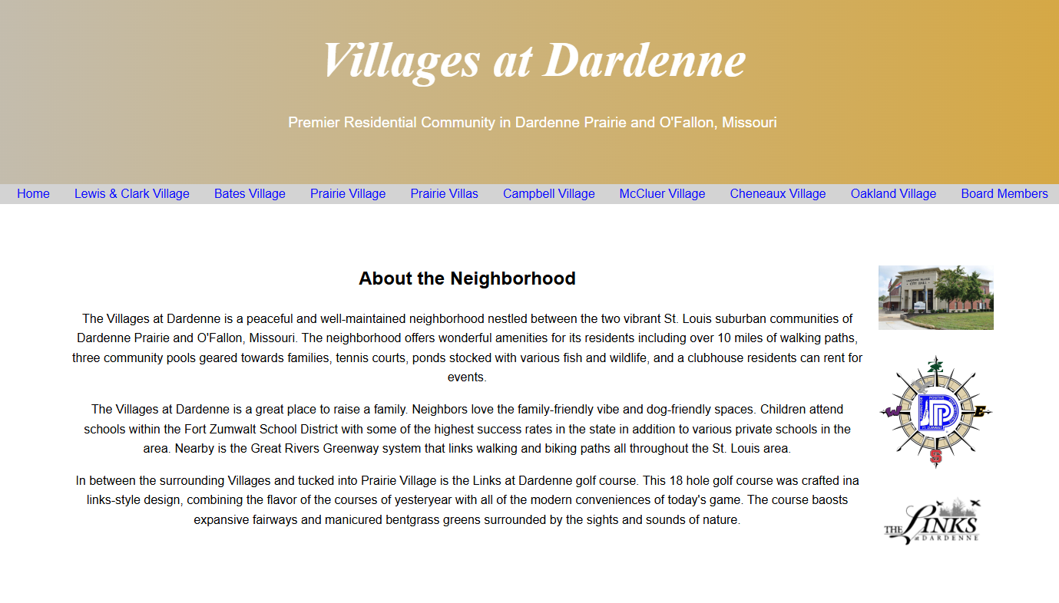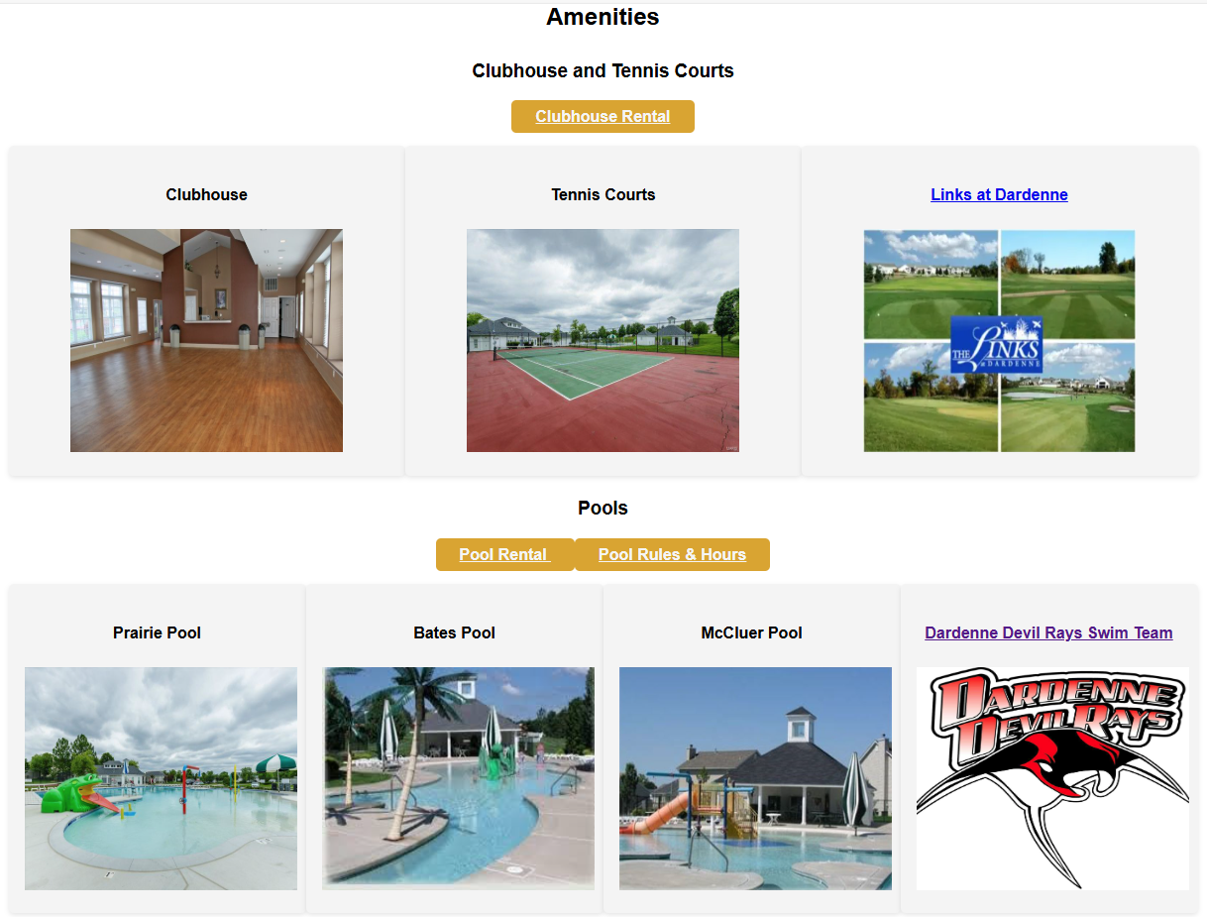

Figure 1: Home page Figure 2: Amenities & Pools

Figure 1 is a screenshot from the home page to describe the neighborhood and city should someone be unfamiliar with the area as well as a snapshot of the amenities that the collective Villages offer. Figure 2 shows other amenities such as the clubhouse, pools, and swim team. The website is positioned to showcase the neighborhoods and its included amenities in order to inform residents as well as attract potential buyers should a real estate agent wish to utilize it. The neighborhood also offers several events and other happenings in the local area to showcase that our city has a lot to offer young families with fliers to be displayed as in Figure 3. Residents also have the ability to add their event to the calendar as shown in Figure 4 so that other neighbors know what may be going on. This could be a garage sale or block party to as broad as a pool party event.

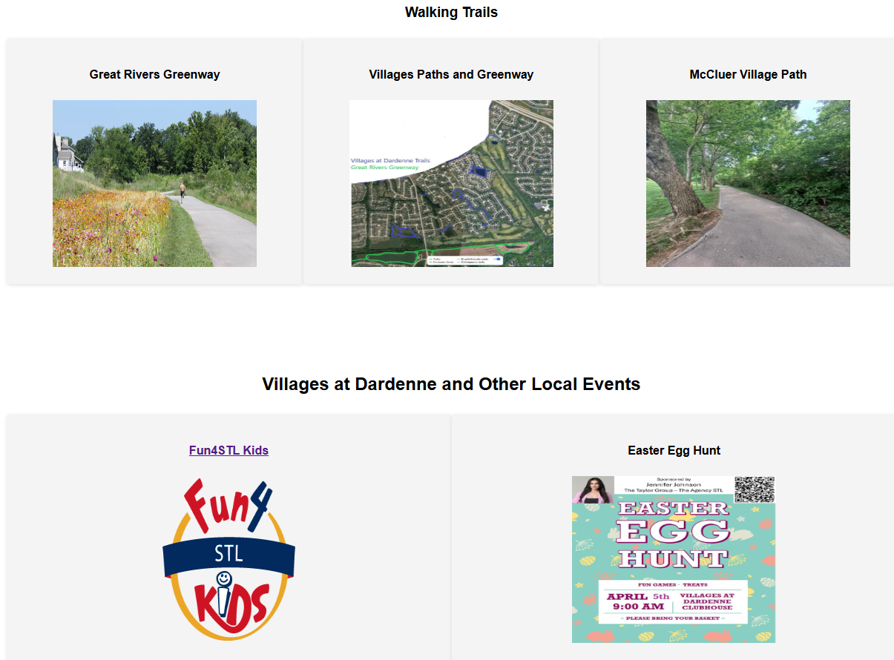 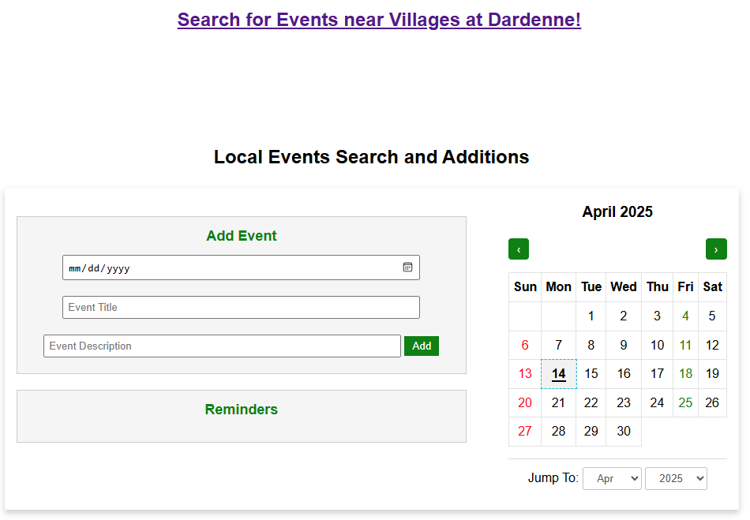

Figure 3: Walking Trails & Events Figure 4: Event Search Link & Calendar

The choice of application was simple: provide as much information for residents and prospective owners as possible to make the role of the homeowners’ association board as simple as possible. The goal of this board has always been to over-communicate to the point of overwhelming which in turn will reduce or eliminate questions. This will also accomplish the goal of the project that our client is seeking.

The website will also reduce questions about service providers and who performs what tasks throughout the neighborhood. The management company that the neighborhood employs to handle all of the behind the scenes work such as accounting, contract negotiations, and fielding resident phone calls is highlighted. The website also highlights the pool company where prospective employees can go to apply for lifeguard positions at any of the pools as well as the landscaping company that maintains multiple acres of common ground and multiple ponds.

In addition to the information for the Master Association each individual Village has its own dedicated webpage where the Board Members can upload events, budgets, documents, and other information that may be useful for their residents. For additional ease of resident use, the Villages are listed on the top navigation header of the Master Association home page.

All of these components make the website a very useful tool for residents, prospective residents, and real estate agents to showcase the neighborhoods as well as provide important information about how the neighborhood operates.

* 1. *Tools/Materials*

The website itself is written utilizing HyperText Markup Language (HTML), Cascading Style Sheets (CSS), and JavaScript utilizing Windows Visual Studio Code to write the code. Each HTML page is linked to the same CSS style sheet for uniformity across each page. The HTML and CSS utilize various containers to keep things in line as well as make it suitable for use on a browser as well as mobile. The ability to flex the style will be crucial to allow the residents to have information at their fingertips. The different sections contain classes that are consistent throughout each page for continued uniformity. Images that enhance the completeness of the website and its contents are utilized and coded with ease of update should they need to be changed in the future by any board member. External links to different aspects tied to the neighborhood are hard coded into the HTML to demonstrate the ability to jump to an external source outside of the internal HTML development. The use of external links was not overly applied in order to make sure the website maintains its self-contained information without leaning too much on outside sources.

JavaScript plays an essential role in the utilization of the event calendar algorithm for adding and deleting events from the calendar. The JavaScript includes buttons for event listeners for date inputs, event titles, and event description. This allows the event to be displayed on the full year calendar as a simple “dot” that demonstrates an event on that date. Residents can then click that date to see event details. Any resident would have the ability to utilize this calendar to add their event. The Reminders section of the event calendar also allows users to delete an event should it be cancelled. The calendar also has a unique function to allow residents to jump to a certain month and year to see what may be coming up.

Also playing an important role in the search function for local events is the use of the Google Programmable Search Engine ([Google](https://programmablesearchengine.google.com/controlpanel/all)). Google’s Programmable Search Engine was chosen after much research into the topic of search-based algorithms to index events including schema.org (Getting started with schema.org using microdata) and UI Automation Activities (HTML Pages). Ultimately, what is needing to be accomplished for the client for this project is a simple search of a unique set of local websites that contain events residents can search on and choose to attend. A Google Programmable Search provides a simple template for web developers to utilize to add to websites to make site search much easier. For this project, we chose to employ this for search of outside websites rather than internal for the betterment of our client. To expand on the algorithm employed for this feature, Google’s Programmable Search Engine does not use binary search directly on the main index, but rather leverages a sophisticated indexing and search architecture. This architecture includes features like keyword indexing and a "divide and conquer" approach for ranking results, which effectively mimics the efficiency of binary search. Instead of a pure binary search algorithm, it employs a more complex system that prioritizes relevance and speed for its search results. Although the Programmable Search Engine is not strictly binary, the appropriate binary pseudocode for this algorithm would be shown as:

FUNCTION binarySearch(sortedList, target):

SET low to the first index of the list

SET high to the last index of the list

WHILE low IS LESS THAN OR EQUAL TO high:

SET mid to the middle index (low + high) / 2

IF sortedList[mid] IS EQUAL TO target:

RETURN mid (index of target)

ELSE IF sortedList[mid] IS LESS THAN target:

SET low to mid + 1

ELSE:

SET high to mid - 1

RETURN -1 (or some indicator that the target was not found)

END FUNCTION

Utilization of a binary algorithm paired with Google’s Programmable Search Engine will allow residents to search what they are looking for by title, date, etc. to become more involved in the community. This algorithm and feature can be further developed in the future depending on more fully-developed user needs.

The last tool used involved creating a database to link the Board Member site within the webpage. In order to allow Board Members to search for residents and determine if their dues have been paid, a database has been established utilizing MySQL Workbench 8.0. The database was created by uploading a CSV file into MySQL Workbench and creating the table with the appropriate header including, homeowner name, address, phone, dues paid, and Village. The original data set only included homeowner name, address, phone, and email. Additional manipulation needed to occur to the data set once in MySQL to update the Village associated with the street name. A query was developed to alter the table using the following syntax:

ALTER TABLE *masterdirectory*

ADD *village text*;

This allowed the table to updated to list the correct Village based on the street names. The data needed to further be manually manipulated by adding if dues were paid or not. This was a manual task that required the Board to check their rosters and provide directly to the project team. A column was then added to the table called “dues paid” that is simple NULL or NOT NULL with blanks being left.

Linking the database into HTML wound up being the most difficult portion of the entire project. Many sources were sought including PHP, PHPMyAdmin (https://www.w3schools.com/php/php_mysql_create.asp), and Node.js. Ultimately, the project team settled on using a .php file to link the MySQL database into HTML. The coding portion was simple, but it required several attempts to ensure the code was accurate. As of this report, connection issues between HTML and MySQL via the PHP connection persist. More troubleshooting will be required to determine if the errors are with the connection to MySQL or the code written in PHP. The figures below demonstrate a successful attempt at the query with the code as written directly from the website:

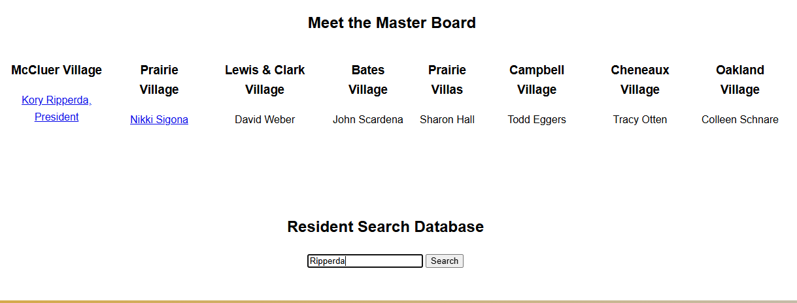

Figure 5: Search by name “Ripperda”





Figure 6: Search Results

1. **Results**
   1. *Project Results*

The project came together after considerable research to make all of the pieces fit. The HTML and CSS were very successful in providing a platform for the information that is required to make the application successful for the client. The amount of artifacts required to make each page look refined and feel like the most important information is contained within the website was far underestimated. Each individual Village page required multiple pictures of amenities including pool and ponds as well as the documents that resident need continued access to such as CC&R’s and budget tables. It will be the task of the client to maintain the budget tables and make any updates to the CC&R’s as necessary. The client intends to update the budget tables monthly, which should be an easy task by simply renaming the file the same as the previous month and saving it in the designated folder.

The ability to search for events in the area has been an improvement upon previously scouring the web for events that may be of interest. Just putting an event out on the main page will make an impact for the client as their residents receive the amount of communication they have desired since 2020. The search function pulls from the City of Dardenne Prairie, the City of O’Fallon, St. Charles County events calendar, and fun4stlkids.com. All of these websites contain events for families of all ages that are local, price sensitive, and intended to be fun. This will allow residents to search for anything they may be looking for to entertain their families.

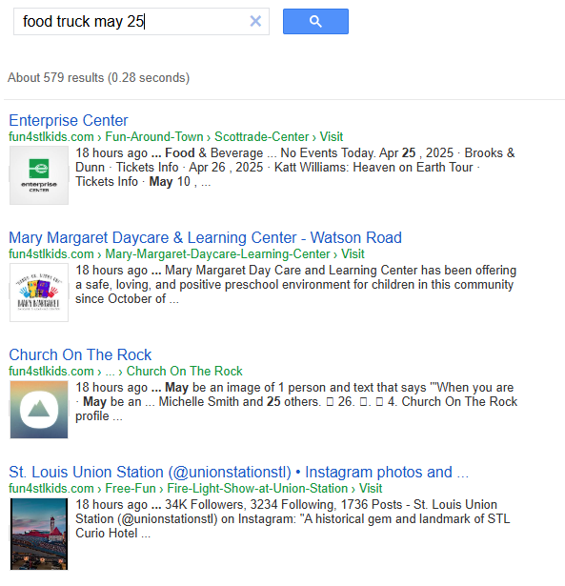

Figure 7: Search Algorithm Sample Results

The event calendar will be heavily utilized by the residents as well as it will be the first stop for them to see when certain Villages events, such as the garage sale, will be taking place. This aspect will see many benefits for the client as they ask questions on Facebook pages rather than attempting to find a source for collective events.

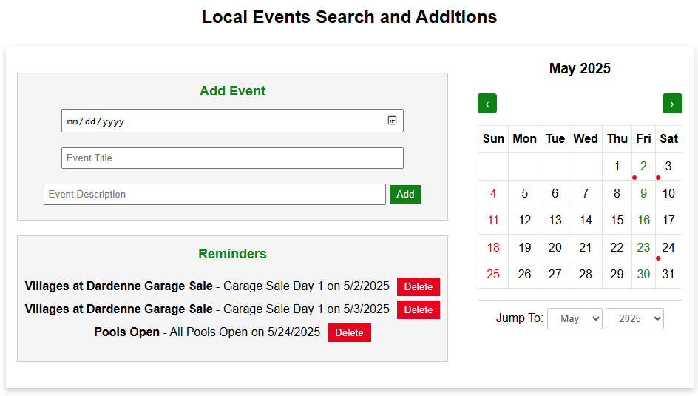

Figure 8: Local Events Calendar Specific to Villages at Dardenne Events

The figures below represent how the website structure has evolved from the original proposal.

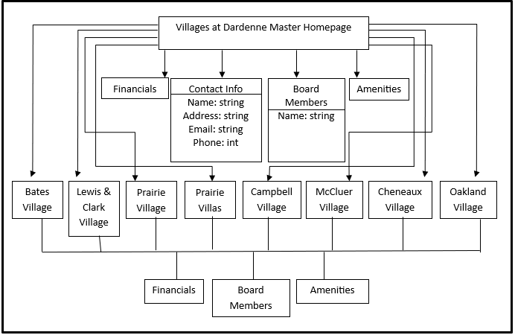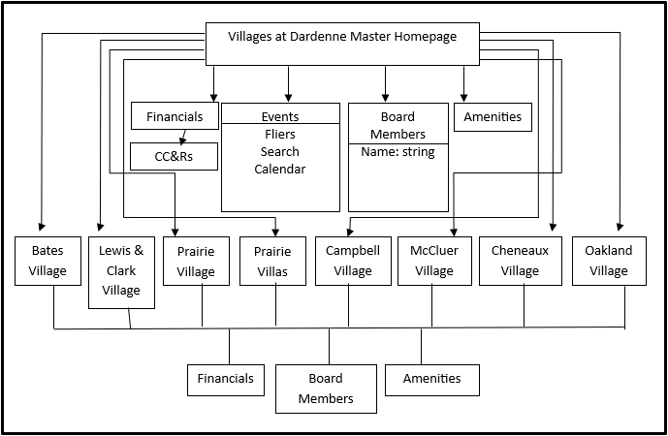

Figure 9: Website Structure – Original Figure 10: Website Structure - Final

The only major change to the structure as shown in Figure 8 is the evolution of the Events section of the website. The original proposal intended to demonstrate search capabilities of an internal database of residents. That priority was shifted to the Board Members page to house the internal database. The main page search function turned into an events search as previously described.

The UML Diagram above demonstrates the goal of the database construct to allow Board Members to search for residents. For clarity, the search function is accessible to all residents at this time even though it is housed under the Board Members tab. Anyone would be able to search by Village and populate a list of residents in that Village. Figure 10 shows an example of such a search.

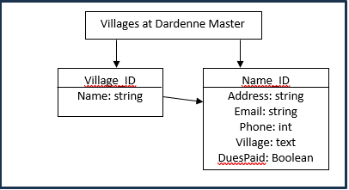

Figure 11: UML Diagram

The ability to search for residents by Village was a highly sought feature by the client. Figures 12 and 13 demonstrate the search from the Board Members page for all “Lewis & Clark” residents.

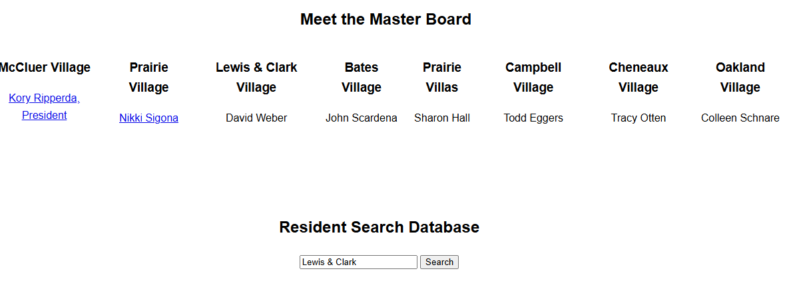

Figure 12: Search for Lewis & Clark residents

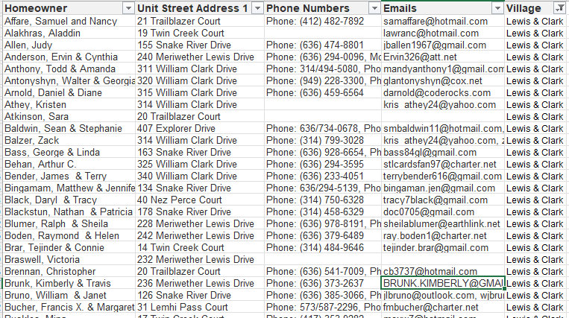

Figure 13: Lewis & Clark Sample Output

* 1. *Adherence to Timeline*

The original proposed timeline was completion of the entire project within 6 weeks. The project team is happy to report that the project took just about 5 weeks. The longest lead time item was the collection of the artifacts for each individual Village. This took time to gather from the client. However, the project team was able to implement placeholders for those items to simply be added to the appropriate folders and coded properly once added. The HTML and CSS activities were the most time intensive as much manual manipulation occurred to make sure the code worked as intended and showed what the client had intended. The ability to code the database into the HTML and link the two items via PHP was another item that took time and effort for research as well as trial and error for proper function. Algorithm research was warranted to ensure the proper implementation of the search algorithm into the HTML for functionality.

The ability to estimate development timelines came into play with this project as the project team anticipated much more time required for the database and search algorithm. The original estimation was that the HTML and CSS would take little to now time which did not end up being the case. In order to improve on the estimate, the project team should ensure that the intent of the client is understood before starting development. In a perfect world, the client would have the majority of the artifacts necessary to add to the application. However that is not always the case when the artifacts are evolving. The whole scope of the project may not be immediately known upon contracting with the project team, however constant communication with the client will be of continued importance to ensure requirements are met.

* 1. *Future Work*

The project is in great position to be deployed for use of the client as it currently stands. Items that would require further refinement include:

Login and password for Board Members to access resident information

Expanding on the search algorithm to include other local event webpages

Continued updates of budgets and documents as necessary

Interactive map of local trails and pathways

Many of these items are dependent on the client to accomplish. However with a longer timeline, the project team would have the ability to create more safety and credibility for our client by locking down resident information behind a password protected environment. As the client does not intend to launch the application immediately, the project team can further refine this requirement should it continue to be needed by the client. The bug in the link between the HTML and database will also need to be fixed which would likely be solved by implementing a password-protected environment for the database portion of the project.

1. **Conclusion**

The project has been successful from a development standpoint and meeting the dates and needs of the client. All of the requirements requested by the client have been met especially adding the ability for residents to have the budget and CC&R information easily accessible. Residents also have the ability to link to the management company’s website to pay their annual or monthly HOA dues. The client also gets several questions about clubhouse and pool rental. These items were specifically addressed with easy to use links to the property management site to rent these amenities offered to residents. The full intention of this project is to fully refine the inputs, reactivate the web domain previously held prior to 2020, and allow this website to become live. As the president of the Master Board, the project team has the means and ability to take this project live and make sure that it is maintained and updated for the betterment of the community.

**References**

4.10.7 The input Element. W3 Schools. (n.d.). https://www.w3.org/TR/2010/WD-html5-20101019/the-input- element.html

Database search function on an HTML page possible?. Stack Overflow. (2012). https://stackoverflow.com /questions/9883511/database-search-function-on-an-html-page-possible

Foley, J., Bendersky, M., & Josifovski, V. (2015). Learning to Extract Local Events from the Web. Google User Content. https://static.googleusercontent.com/media/research.google.com/en//pubs/archive/43796.pdf

GeeksforGeeks. (2024a, August 5). How to create a dynamic calendar in HTML CSS & javascript?. GeeksforGeeks. https://www.geeksforgeeks.org/how-to-create-a-dynamic-calendar-in-html-css-javascript/

Getting started with Schema.org using microdata. Getting Started. (2025, March 24). https://schema.org/docs/gs.html

Google. (n.d.). Programmable Search Engine. Google Accounts. https://programmablesearchengine.google.com/controlpanel/all

HTML Pages: Extract and Manipulate Information . UI Path Documentation. (2025, March 10). https://docs.uipath.com/activities/other/latest/ui-automation/html-pages-extract-and-manipulate-information

W3schools.com. PHP MySQL Create Database. (2025). https://www.w3schools.com/php/php_mysql_ create.asp